**Class diagram:**

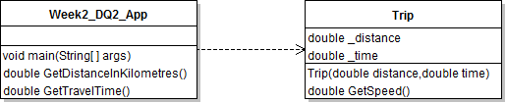

1. **Week2_DQ1_App**

Contain the main logic to interact with user

* Get travel distance and time from user input
* Display the speed of travel

1. **Trip**

The trip class will accept both distance and travel time when the constructor is being invoked. It also contains a method to calculate and return the travel speed